**RAPIDOC HEALTHCARE WEBSITE**

**Table of Contents**

1. Project Overview

2. Objectives

3. Purpose

4. Features and Services

5. Technology Stack

6. Architecture

7. Installation (Prerequisites, Setup)

8. Usage

9. Advantages

10. Disadvantages

11. Future Scope

12. Conclusion

**1. PROJECT OVERVIEW**

RapiDoc is a pioneering digital healthcare platform designed to transform the way users access medical services. As a comprehensive and user-friendly online destination, RapiDoc provides a wide range of essential healthcare services aimed at improving the overall healthcare experience. The platform ensures users can easily locate nearby clinics and labs, access pharmacy deliveries, stay informed about blood bank statuses, and receive regular health updates through our daily feed. With a focus on accessibility, RapiDoc also caters to disabled individuals by listing wheelchair-accessible hospitals and clinics, ensuring no one is left behind in receiving timely and efficient medical care.

The services offered by RapiDoc are meticulously designed to cater to various health needs. Users can book appointments with top-rated doctors specializing in dermatology, gynecology, cardiology, and ENT, ensuring they receive expert medical attention. The platform facilitates normal checkups, blood tests, and provides crucial information about body temperature ranges and medicine usage. Our commitment to health extends beyond immediate medical needs, offering health benefits like bootcamps, vaccination drives, and personalized check-ups. Emergency services are streamlined to help users avoid rush and get immediate assistance, with real-time updates on bed availability at emergency centers. Additionally, RapiDoc's subscription to newsletters keeps users informed with the latest medical insights and health tips. Through our seamless integration of digital solutions, RapiDoc stands as a reliable partner in maintaining and enhancing your health, bringing you the best facilities and ensuring you are well-supported at every digital step.

**2. OBJECTIVES:**

* Provide a comprehensive online destination for essential healthcare services.
* Enable users to easily locate nearby clinics, labs, and pharmacies for their medical needs.
* Keep users informed about blood bank statuses and provide regular health updates through a daily feed.
* Cater to the accessibility needs of disabled individuals by listing wheelchair-accessible hospitals and clinics.
* Offer booking services for appointments with top-rated doctors across various specialties.
* Facilitate normal checkups, and blood tests, and provide crucial information about body temperature ranges and medicine usage.
* Extend health benefits like boot camps, vaccination drives, and personalized check-ups.
* Streamline emergency services to help users avoid the rush and get immediate assistance, with real-time updates on bed availability at emergency centers.
* Provide users with the latest medical insights and health tips through newsletters.
* Ensure seamless integration of digital solutions for a reliable healthcare experience.
* Commit to providing a seamless and efficient healthcare experience for all users.

**3. PURPOSE**

The purpose of the RapiDoc project is to revolutionize the accessibility and delivery of healthcare services through a comprehensive digital platform. It aims to address various needs and challenges faced by individuals seeking medical assistance by providing a user-friendly interface to access a wide range of healthcare services. By leveraging digital solutions, RapiDoc intends to streamline the process of locating nearby clinics, labs, and pharmacies, booking appointments with top-rated doctors, receiving health updates, and accessing emergency services. Additionally, the project aims to cater to the accessibility needs of disabled individuals and keep users informed with the latest medical insights and health tips. Overall, the purpose of RapiDoc is to provide a seamless and efficient healthcare experience for all users, enhancing their well-being and ensuring they receive timely and expert medical attention.

**4. FEATURES AND SERVICES**

**Homepage**

**Welcome Section:** Introduces RapiDoc as a digital healthcare destination, emphasizing the ease and convenience of accessing healthcare services through the platform.

**Download App Button:** Encourages users to download the RapiDoc app for a more integrated experience.

**Services**

**Clinics/Labs:** Helps users locate the best healthcare facilities around them without hassle.

**Pharmacy:** Allows users to get prescribed medicines delivered to their doorstep.

**Daily Feed:** Provides access to health benefits such as bootcamps, vaccination drives, and more.

**Blood Bank:** Offers information about nearby blood banks and available blood groups to ensure no one suffers in emergencies.

**Disabled Person Services:** Lists wheelchair-accessible hospitals and clinics to ensure convenient medical care.

**Health Post:** Delivers health-related content weekly, monthly, yearly, or daily, based on user preference.

**Appointments**

**Make an Appointment:** A form where users can book appointments with doctors. It includes fields for the user's name, email, phone, appointment date, age, location, and an optional message.

**Doctors**

**Specialist Listings:** Lists doctors across various specializations such as Dermatology, Gynecology, Cardiology, and ENT, with options to appoint a doctor directly from the website.

**Contact**

**Feedback Form:** Allows users to provide feedback and suggestions to help improve digital medical care.

**Contact Information:** Provides the platform's contact details, including location, email, and phone number.

**Address**: Lists the address as Delhi, India.

**Links**: Includes quick links to important sections of the website such as Home, About Us, Services, Doctors, and Contact.

**Newsletter Subscription**

**Daily Newsletter:** Encourages users to subscribe to receive medical insights and updates via email.

**5. TECHNOLOGY STACK**

* Frontend: HTML5, CSS, JavaScript, BootStrap
* Integrated Development Environment (IDE): VS Code/Google IDX
* Version Control: Git and GitHub

**6. ARCHITECTURE**

Here is the architecture diagram of Rapidoc healthcare application.

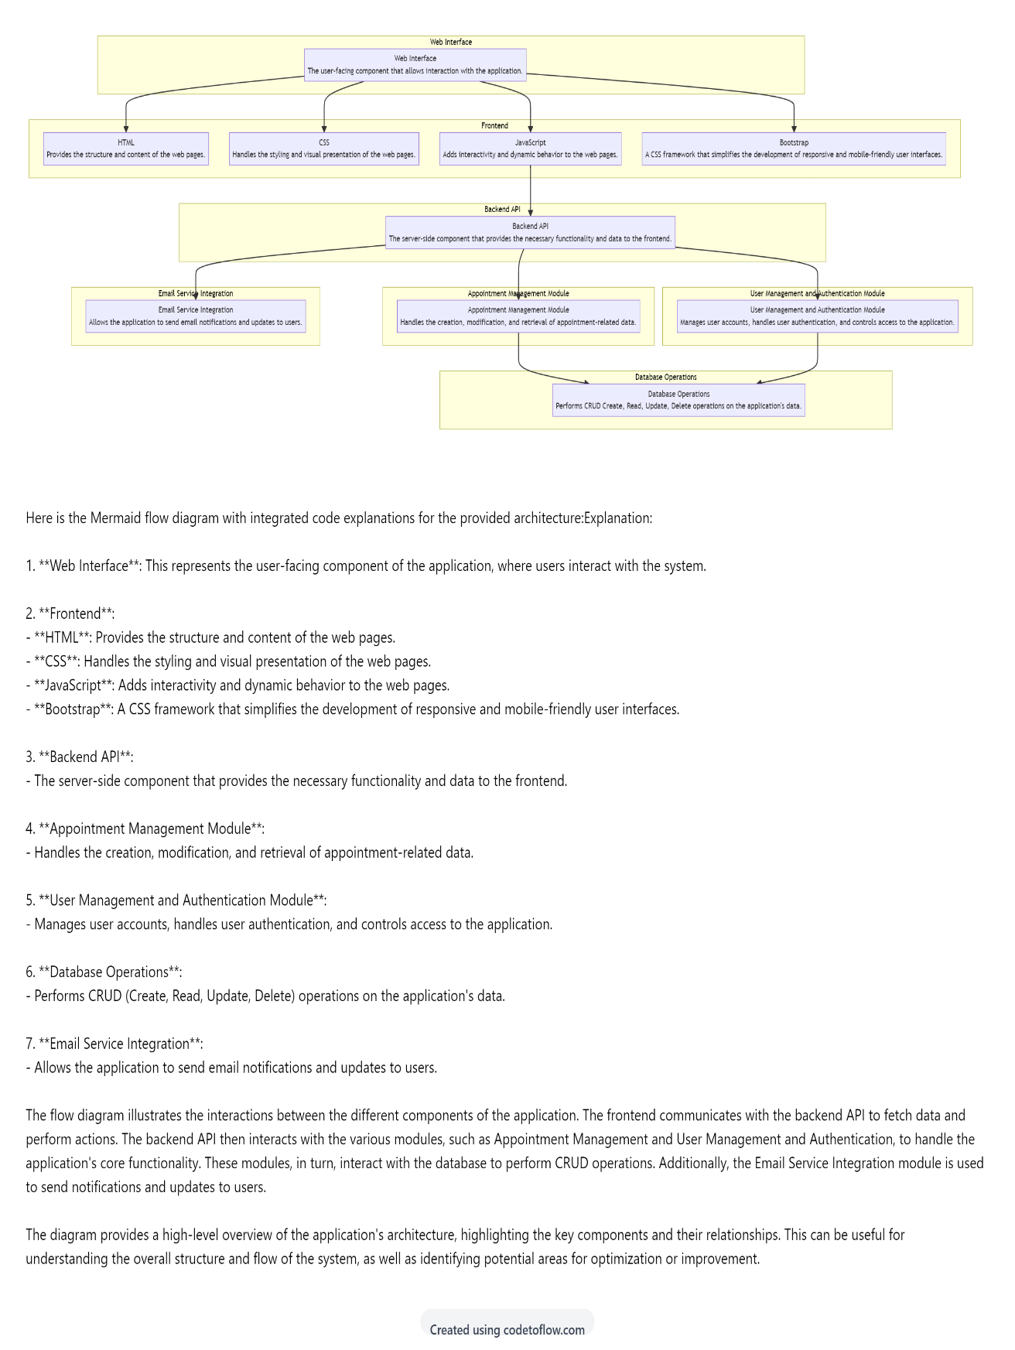

This is the flow of operations , which can be done through the rapidoc application. The provided architecture diagram outlines the flow of operations within the RapiDoc application, illustrating how data and control move through the various components.

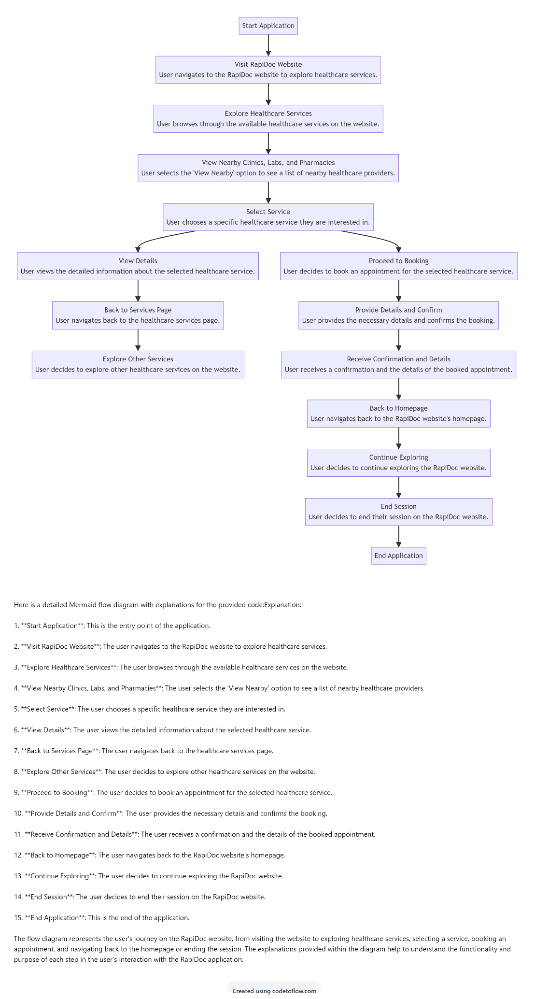

**7. INSTALLATION**

To run the project locally in your System

1. Fork the Repository: Click on the "Fork" button on the repository's GitHub page to create a copy of the repository in your GitHub account.

2. Clone the repository: Clone the forked repository to your local machine using the following command in your terminal.

git clone   
https://github.com/<your-github-username>/RAPIDOC-HEALTHCARE-WEBSITE

3. You can make changes in code using the VS code text editor.

4. Find the Index.html file: Right click the file mentioned and click on "Open with Live Server" This will redirect to the web-browser and load the landing page of the project

**8. USAGE**

**Accessing the Website:**

Users start by accessing the RapiDoc website through their web browser on any internet-enabled device.

**Exploring Healthcare Services:**

Upon landing on the homepage, users can explore the various healthcare services offered by RapiDoc. This includes services such as locating nearby clinics, labs, and pharmacies, booking appointments with doctors across different specialties, accessing blood bank statuses, and receiving regular health updates.

**Locating Nearby Healthcare Facilities:**

If a user is in need of immediate medical assistance or wants to schedule an appointment, they can use the website to locate nearby healthcare facilities such as clinics, labs, and pharmacies. The website provides information on the location, services offered, and contact details of these facilities.

**Booking Appointments:**

Users can book appointments with top-rated doctors specializing in various fields like dermatology, gynecology, cardiology, and ENT. They can browse through available appointment slots, select a convenient time, and provide necessary details to confirm the booking.

**Accessing Medical Information:**

RapiDoc provides users with access to crucial medical information such as body temperature ranges, medicine usage guidelines, and general health tips. Users can stay informed about various health topics through the website's daily feed and newsletter subscriptions.

**Emergency Services:**

In case of emergencies, users can use the website to access streamlined emergency services. Real-time updates on bed availability at emergency centers help users make informed decisions and get immediate assistance when needed.

**Staying Updated:**

Users can stay updated with the latest medical insights and health tips by subscribing to RapiDoc's newsletters. This ensures that they receive timely information about healthcare developments and best practices.

**Navigating the Website**:

Throughout their interaction with the website, users can easily navigate between different pages using intuitive navigation menus and links. The website's user-friendly interface ensures a smooth and seamless browsing experience.

**Contacting RapiDoc:**

For further inquiries or assistance, users can easily get in touch with RapiDoc through the provided contact information, including email and phone number.

**9. ADVANTAGES:**

Here are the advantages of Rapidoc healthcare service

* Convenient access to healthcare services and medical information anytime, anywhere.
* User-friendly interface for easy navigation and quick appointment bookings.
* Timely updates on bed availability at emergency centers for informed decision-making during emergencies.
* Ability to book appointments with top-rated doctors across various specialties.
* Access to regular health updates and informative newsletters for staying informed.
* Streamlined emergency services to ensure prompt assistance when needed.

**10. DISADVANTAGES**

These are the disadvantages of Rapidoc healthcare service

* Potential privacy concerns related to storing personal health information online.
* limiting usage in areas with poor connectivity.

**11. FUTURE SCOPE**

* Expansion of Services: Introduce additional healthcare services like telemedicine consultations and home healthcare.
* AI-powered Virtual Health Assistants, Develop AI-driven assistants for round-the-clock support and health advice.
* Geographical Expansion: Expand services globally by partnering with healthcare providers worldwide.

**12. CONCLUSION**

The RapiDoc healthcare website stands as a very useful digital platform dedicated to transforming healthcare accessibility. By providing comprehensive and user-friendly services, RapiDoc revolutionizes how users access medical care, ensuring convenience and efficiency. With features ranging from appointment booking with top-rated doctors to real-time updates on emergency bed availability, RapiDoc addresses diverse healthcare needs. Moreover, its commitment to accessibility ensures no one is left behind in receiving timely medical care. While the platform offers numerous advantages such as easy access to healthcare services and informative updates, it also faces challenges such as potential privacy concerns and dependency on internet connectivity. Looking ahead, RapiDoc has promising future scope areas, including the expansion of services, integration of AI-driven virtual health assistants, and geographical expansion. In essence, RapiDoc emerges as a reliable partner in promoting well-being and enhancing the healthcare experience for all users.